A Community Guide to
Advocating for Your Health
Helping Caribbean communities explain their health clearly, understand why care can be missed, and know what to do next
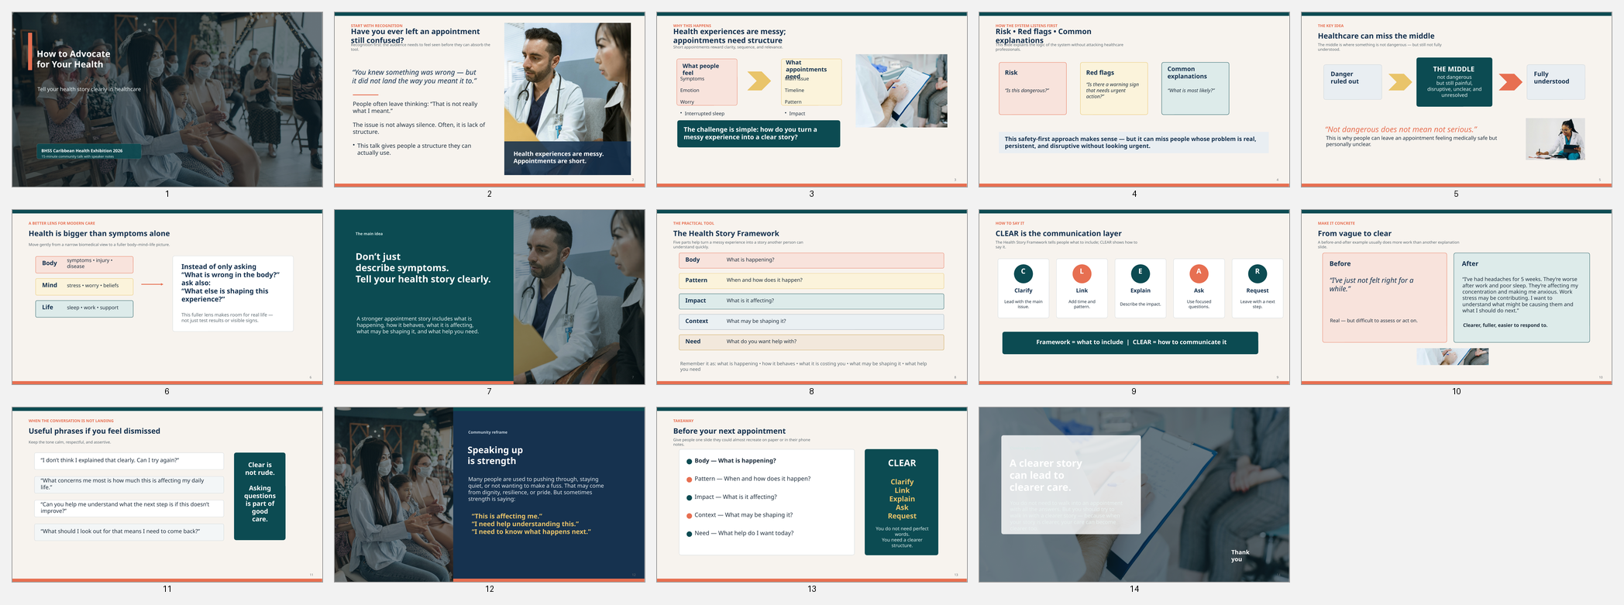
Prepared for community health education and advocacy
BHSS Community Resource • 2026
Important note. This guide is for education and self-advocacy. It is not a diagnosis tool and it does not replace medical care. If symptoms are severe, sudden, worsening, or feel like an emergency, seek urgent medical help.

How to use this guide
This ebook turns the key ideas from our community presentation into a practical guide. It is designed to help people prepare for appointments, describe symptoms more clearly, show how health problems affect daily life, and ask better questions when they need care.
You do not need to use every page at once. Read the sections that fit your situation. You can also use the worksheets at the end as a step-by-step appointment planner.

What you will learn
- Why people can leave appointments feeling unheard, unclear, or stuck.
- How healthcare often listens for risk, red flags, and the most common explanation first.
- Why a problem can be 'not dangerous' but still very serious in real life.
- How to move beyond vague symptom descriptions and tell a clearer health story.
- How to use the Health Story Framework and CLEAR communication method.
- What to say before, during, and after appointments - especially if you feel dismissed.

Contents
- Why advocacy matters
- Why people can be missed in healthcare
- The limits of a body-only view of health
- The middle: where many people get stuck
- The Health Story Framework
- CLEAR communication in appointments
- What to say if you feel dismissed
- Before, during, and after your appointment
- Family, culture, and community
- Practical tools and worksheets

1. Why advocacy matters
Many people do the right thing: they book the appointment, turn up, explain that something is wrong, and hope to leave with answers. Yet many still leave feeling unheard, confused, or not fully helped. That experience is common, and it does not mean your problem is unimportant.
Self-advocacy in healthcare is not about arguing, exaggerating, or trying to 'win' an appointment. It is about making your health experience easier to understand, harder to overlook, and clearer to act on.
Good advocacy helps with three things:
- It gives healthcare professionals a clearer signal.
- It reduces the chance that important details stay unspoken.
- It helps you leave with more clarity about what happens next.

A simple truth
Many people are not ignored because their problem is minor. They are often misunderstood because health experiences are messy, while appointments are short and structured.
That is why this guide keeps returning to one idea:
Do not just describe symptoms - tell your health story clearly.

2. Why people can be missed in healthcare
Many people assume that if they say they are in pain, tired, worried, or struggling, the seriousness will be obvious. Sometimes it is. But often the healthcare system is filtering what it hears in a different way.

How healthcare often listens
In many appointments, the first questions are not 'What is your full story?' They are more like:
- Is this dangerous?
- Are there red flags or warning signs?
- What is the most common explanation?
This makes sense in a pressured system. Clinicians must prioritise safety, rule out urgent problems, and work efficiently. But this style of listening can leave gaps.

What patients often hope for
Patients often want four things: to be listened to, to understand what might be going on, to know whether something serious has been ruled out, and to leave with a clear next step.
When the system focuses first on danger and likelihood, and the patient hopes for explanation and clarity, both sides can leave the conversation feeling incomplete.

Common reasons people are misunderstood
- The description is too general: 'I just don't feel right.'
- The timeline is unclear: the person jumps around the story.
- The impact on daily life is never explained.
- Stress, sleep, work, caring, or fear are shaping the issue but never mentioned.
- The person minimises the problem because they do not want to make a fuss.
- The appointment ends without a clear plan.

3. The limits of a body-only view of health
Healthcare has often been shaped by a biomedical way of thinking. In that model, illness is mainly understood as something physically wrong in the body: a disease, injury, infection, or measurable problem that should be found and treated.
This approach is excellent for many situations, especially emergencies, infections, trauma, surgery, and clearly defined disease. But it does not explain everything people live through.

Why the body-only view is not enough
- Symptoms do not always match scans or test results.
- Two people with the same diagnosis can function very differently.
- Stress, grief, poor sleep, and life pressure can worsen physical symptoms.
- Fear and uncertainty can change what people avoid, tolerate, and communicate.
- Family roles, work conditions, money stress, and support systems affect recovery.
This is why many modern health conversations now refer to a broader view: health is shaped by the body, the mind, and the life a person is living. In plain language, your health story is not just about what hurts. It is also about what is affecting it, what it is costing you, and what help you need.

What this broader view means for appointments
It does not mean that symptoms are 'all in your head'. It means symptoms should be understood in context. A person with pain may also be sleeping badly, carrying family responsibilities, worried about work, and becoming less active out of fear. All of that matters when care is planned.

4. The middle: where many people get stuck
One of the most important ideas in this guide is 'the middle'. The middle is the space where a problem is not obviously dangerous, but it is still not fully understood.
What the system may say | What the person may feel | Why the gap matters
'We are not seeing anything serious right now.' | 'But I still cannot sleep, work, move properly, or think clearly.' | The appointment may be clinically safe, yet still feel personally incomplete.

Seven important gaps in the middle
1. Not dangerous does not mean not serious. A problem can still damage sleep, work, mobility, confidence, and family life even if it is not life-threatening.
2. Ruling out red flags does not explain the cause. Being told that nothing serious is showing up is not the same as understanding why something started or why it keeps returning.
3. Common explanations can miss individual reality. What is most likely across a population is not always the full story for one person.
4. Screening is not the same as understanding. An appointment may be built to sort and triage first, not fully solve everything in one conversation.
5. Clinical safety is not the same as patient clarity. A clinician may feel reassured while the patient still feels confused and unsupported.
6. Symptoms alone can hide the real impact. If you only say what you feel, and not what it is stopping you doing, the seriousness may be underestimated.
7. Single-issue thinking can miss the whole person. Real life is connected. Pain, sleep, stress, mood, confidence, and daily function often overlap.

5. The Health Story Framework
The best way to bring more clarity into an appointment is to organise your experience before you speak. The Health Story Framework helps you do that. It moves you from a loose symptom description to a fuller picture.

The five parts of a clear health story
Part | What it means | Useful prompts
Body | What is happening physically? | What is the main issue? Where is it? How long has it been there?
Pattern | How does it behave? | When does it happen? What makes it better or worse? Is it changing?
Impact | What is it affecting? | How is it affecting sleep, work, movement, mood, or daily tasks?
Context | What may be shaping it? | Could stress, poor sleep, work pressure, caring, or life changes be involved?
Need | What do you want help with? | What do you want to understand, ask for, or happen next?

A before-and-after example
Before: 'I've just not felt right for a while.'
After: 'I've had headaches for 5 weeks. They're worse after work and poor sleep. They're affecting my concentration and making me anxious. Work stress may be contributing. I want to understand what might be causing them and what I should do next.'
The second version is not dramatic. It is simply clearer. It gives the listener something they can act on.

6. CLEAR communication in appointments
The Health Story Framework helps you know what to include. CLEAR helps you know how to say it.
Letter | Meaning
C | Clarify the main problem
L | Link it to time and pattern
E | Explain the impact
A | Ask focused questions
R | Request the next step

Useful questions to ask
- What do you think could be causing this?
- What else should we rule out?
- What are my options from here?
- What should I monitor over the next few days or weeks?
- At what point should I come back if this does not improve?
- If this approach does not help, what is the next step?

Helpful scripts
- I want to make sure I explain this clearly.
- The main issue I want help with today is ...
- What concerns me most is how this is affecting my daily life.
- Can you help me understand what the next step is if this does not improve?
- I do not think I explained that clearly. Can I try again?

7. What to say if you feel dismissed
Feeling dismissed does not always mean someone intended to dismiss you. Sometimes the appointment has moved on too quickly, or your main concern has not landed clearly. Calm, respectful repetition can help.

Phrases that can reset the conversation
- I understand, but I am still worried because this has been persistent.
- What concerns me most is the effect on my sleep, work, or daily life.
- Can you help me understand why no further action is needed right now?
- What should I look out for that means I need to come back sooner?
- If this continues, what would the next step be?
Being assertive is not the same as being rude. Clear questions protect clarity. They also help you avoid leaving the room not knowing what happens next.

8. Before, during, and after your appointment

Before
- Write down your main issue in one sentence.
- Note how long it has been happening and what the pattern is.
- List two or three ways it is affecting daily life.
- Think about any stress, sleep changes, work pressure, or responsibilities that may be relevant.
- Decide what you most want from the appointment: explanation, reassurance, advice, review, referral, or a plan.

During
- Lead with the main issue first.
- Use the Body - Pattern - Impact - Context - Need structure.
- Speak slowly enough to keep your own thoughts clear.
- Ask focused questions.
- If needed, say: 'I want to make sure I understand what happens next.'

After
- Write down what was said while it is still fresh.
- Note any advice, medication, tests, referrals, or warning signs to monitor.
- If you do not understand the plan, ask again or seek clarification.
- If things are not improving, use your notes to return with a clearer update.

9. Family, culture, and community
This guide is written with Caribbean communities in mind, but many of these patterns apply more broadly. In some families and communities, people are used to pushing through, being resilient, keeping private matters private, or not wanting to make a fuss.
Those qualities can reflect strength, pride, dignity, and survival. But sometimes the same habits can also mean symptoms are minimised, care is delayed, or important details stay unspoken.

A more helpful reframe
- Instead of 'I do not want to bother anyone,' try: 'My health matters, and clear communication helps care work better.'
- Instead of 'I should just push through it,' try: 'Strength also means knowing when to seek help and speak clearly.'
- Instead of 'If it is not an emergency, I should stay quiet,' try: 'Not dangerous does not mean not serious.'
One of the healthiest messages a community can share is this: strength is not always staying silent. Sometimes strength is speaking clearly.

10. Practical tools and worksheets

Quick appointment planner
My main issue
____________________________________________________________________________
____________________________________________________________________________
Pattern / timing
____________________________________________________________________________
____________________________________________________________________________
How it affects daily life
____________________________________________________________________________
____________________________________________________________________________
Possible context
____________________________________________________________________________
____________________________________________________________________________
What I need help with
____________________________________________________________________________
____________________________________________________________________________
Questions I want answered
____________________________________________________________________________
____________________________________________________________________________

My one-minute health story
Use this sentence builder:
The main issue I want help with is ...
____________________________________________________________________________
It has been happening since ... and it is usually worse when ...
____________________________________________________________________________
It is affecting my ...
____________________________________________________________________________
Things that may be shaping it include ...
____________________________________________________________________________
Today I want help to understand / do / decide ...
____________________________________________________________________________

Red flag reminder
This guide is about better communication, but some symptoms should not wait for routine self-advocacy alone. Seek urgent help or follow emergency guidance if you have signs such as severe chest pain, sudden weakness or facial droop, major breathing difficulty, heavy bleeding, confusion, collapse, suicidal crisis, or anything that feels acutely dangerous.

Final message
You do not need to walk into an appointment with all the answers. But it helps to walk in with a clearer story. When your story is clearer, your care can become clearer too.
Remember the core tools:
- Tell your health story: Body - Pattern - Impact - Context - Need
- Communicate with CLEAR: Clarify - Link - Explain - Ask - Request
- Not dangerous does not mean not serious
- Strength is not always staying silent - sometimes strength is speaking clearly
End of guide

